### Practical File

### Of

### Problem Solving using Python Programming

### 24CSE0101

#### Submitted

#### in partial fulfillment for the award of the degree of

## BACHELEOR OF ENGINEERING

***in***

COMPUTER SCIENCE & ENGINEERING



**CHITKARA UNIVERSITY**

**CHANDIGARH-PATIALA NATIONAL HIGHWAY**

**RAJPURA (PATIALA) PUNJAB-140401 (INDIA)**

##### December, 2024

##### **Submitted To: Submitted By:**

##### Faculty name: Dr.Harmanjeet Singh Name:Akashdeep Singh

##### Designation: Associate Professor RollNo : 2410990904

##### Chitkara University, Punjab 1st Sem, Batch2024

**INDEX**

|  |  |  |
| --- | --- | --- |
| **Sr. No.** | **Practical Name** | **Teacher Sign** |
| 1 | a) Write a [Python Program to Calculate the Area of a Triangle](https://www.programiz.com/python-programming/examples/area-triangle)  b) Write a [Python Program to Swap Two Variables](https://www.programiz.com/python-programming/examples/swap-variables)  c) Write a [Python Program to Convert Celsius to Fahrenheit](https://www.programiz.com/python-programming/examples/celsius-fahrenheit) |  |
| 2 | a) Write a [Python Program to Check if a Number is Odd or Even](https://www.programiz.com/python-programming/examples/odd-even)  b) Write a [Python Program to Check if a Number is Positive, Negative or 0](https://www.programiz.com/python-programming/examples/positive-negative-zero)  c) Write a [Python Program to Check Armstrong Number](https://www.programiz.com/python-programming/examples/armstrong-number) |  |
| 3 | a) Write a Python program to check if a given number is Fibonacci number?  b) Write a Python program to print cube sum of first n natural numbers.  c) Write a Python program to print all odd numbers in a range. |  |
| 4 | a) Write a Python Program to Print Pascal Triangle  b) WAP to Draw the following Pattern for n number. |  |
| 5 | Write a program with a function that accepts a string from keyboard and create a new string after converting character of each word capitalized. |  |
| 6 | a) Write a program that accepts a list from user. Your program should reverse the content of list and display it. Do not use reverse () method.  b)  Find and display the largest number of a list without using built-in function max (). Your program should ask the user to input values in list from keyboard. |  |
| 7 | Find the sum of each row of matrix of size m x n. |  |
| 8 | a) Write a program that reads a string from keyboard and display:  * The number of uppercase letters in the string.  * The number of lowercase letters in the string.  * The number of digits in the string.  * The number of whitespace characters in the string.  b) [Python Program to Find Common Characters in Two Strings](https://www.sanfoundry.com/python-program-check-common-letters-string/).  c) [Python Program to Count the Number of Vowels in a String](https://www.sanfoundry.com/python-program-count-number-vowels-string/). |  |
| 9 | Write a Python program to check if a specified element presents in a tuple of tuples. |  |
| 10 | Write a Program in Python to Find the Differences Between Two Lists Using Sets. |  |
| 11 | a) Write a Python program Remove duplicate values across Dictionary Values.  b) Write a Python program to Count the frequencies in a list using dictionary in Python. |  |
| 12 | a) Write a Python Program to Capitalize First Letter of Each Word in a File. b.) Write a Python Program to Print the Contents of File in Reverse Order |  |
| 13 | WAP to catch an exception and handle it using try and except code blocks. |  |
| 14 | Write a Python Program to Append, Delete and Display Elements of a List using Classes. |  |
| 15 | Write a [Python Program to Find the Area and Perimeter of the Circle using Class](https://www.sanfoundry.com/python-program-class-compute-area-perimeter-circle/) |  |
| 16 | Create an interactive application using Python's Tkinter library for graphics programming. |  |

**Program 1:**

**Title of program:** Write a [Python Program to Calculate the Area of a Triangle](https://www.programiz.com/python-programming/examples/area-triangle)

**Objective:** This program will calculate the area of triangle when we will give measure of side.

**Code:** def calculate_triangle_area(base, height):

return 0.5 * base * height

base = float(input("Enter the base of the triangle: "))

height = float(input("Enter the height of the triangle: "))

area = calculate_triangle_area(base, height)

print("The area of the triangle is",area)

**Input:** Base : 10

Height : 10

**Result:**

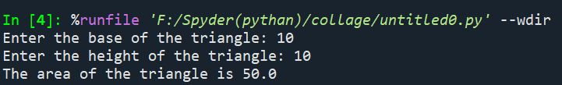

**Title of program:** Write a [Python Program to Swap Two Variables](https://www.programiz.com/python-programming/examples/swap-variables)

**Objective:** This program will swap the 2 variables entered by us.

**Code:** a=int(input("Enter a number:"))

b=int(input("Enter a number:"))

t=a

y=b

print("After swapping")

print("a=",y)

print("b=",t)

**Input:** a (first variable) = 10

b (second variable) = 11

**Result:**

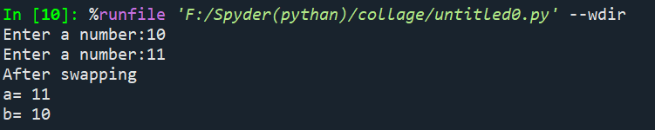

**Title of program:** Write a [Python Program to Convert Celsius to Fahrenheit](https://www.programiz.com/python-programming/examples/celsius-fahrenheit).

**Objective:** This program will help us to convert Celsius into Fahrenheit.

**Code:** def celsius_to_fahrenheit(celsius):

return (celsius * 9/5) + 32

celsius = float(input("Enter temperature in Celsius: "))

fahrenheit = celsius_to_fahrenheit(celsius)

print(celsius,"°C is equal to",fahrenheit,"°F")

**Input:**  Celsius = 10

**Result:**

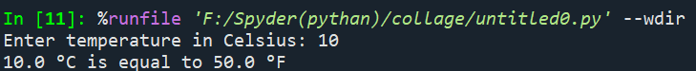

**Program 2:**

**Title of program:** Write a [Python Program to Check if a Number is Odd or Even](https://www.programiz.com/python-programming/examples/odd-even).

**Objective:** This program will help us to check weather a number is odd or even .

**Code:** def check_odd_even(number):

if number % 2 == 0:

return "Even"

else:

return "Odd"

number = int(input("Enter a number: "))

result = check_odd_even(number)

print("The number",number,"is",result)

**Input:** Number to be checked = 10

**Result:**

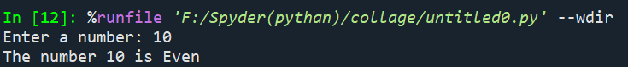

**Title of program:** Write a [Python Program to Check if a Number is Positive, Negative or 0](https://www.programiz.com/python-programming/examples/positive-negative-zero).

**Objective:** This program helps us to check the number is positive, negative or zero.

**Code:** def check_number(number):

if number > 0:

return "Positive"

elif number < 0:

return "Negative"

else:

return "Zero"

number = float(input("Enter a number: "))

result = check_number(number)

print("The number","is",result)

**Input:** Enter number = 10

**Result:**

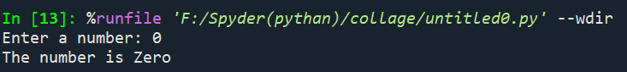

**Title of program:** Write a [Python Program to Check Armstrong Number](https://www.programiz.com/python-programming/examples/armstrong-number).

**Objective:** This program checks whether the number is Armstrong number or not.

**Code:**  def is_armstrong(number):

digits = str(number)

num_digits = len(digits)

sum_of_powers = sum(int(digit) ** num_digits for digit in digits)

return sum_of_powers == number

number = int(input("Enter a number: "))

if is_armstrong(number):

print(number,"is an Armstrong number.")

else:

print(number,"is not an Armstrong number.")

**Input:** Number = 1203

**Result:**

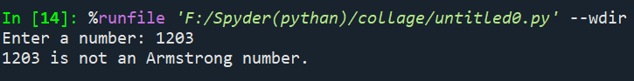

**Program 3:**

**Title of program:** Write a Python program to check if a given number is Fibonacci number?

**Objective:** This program checks whether the number is Fibonacci or not.

**Code:** import math

def is_perfect_square(x):

s = int(math.sqrt(x))

return s * s == x

def is_fibonacci_number(n):

return is_perfect_square(5 * n * n + 4) or is_perfect_square(5 * n * n - 4)

number = int(input("Enter a number: "))

if is_fibonacci_number(number):

print(number, "is a Fibonacci number.")

else:

print(number,"is not a Fibonacci number.")

**Input:** Number =1231

**Result:**

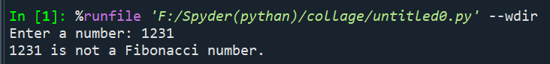

**Title of program:** Write a Python program to print cube sum of first n natural numbers.

**Objective:** This program helps us to find cube sum of first n natural number.

**Code:** def cube_sum(n):

return sum(i**3 for i in range(1, n+1))

n = int(input("Enter the value of n: "))

result = cube_sum(n)

print("The cube sum of the first",n,"natural numbers is",result)

**Input:** value of n = 31312

**Result:**

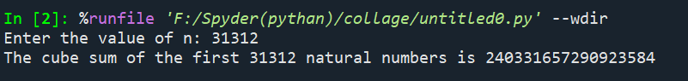

**Title of program:** Write a Python program to print all odd numbers in a range.

**Objective:** This program helps print all odd numbers in range.

**Code:** def print_odd_numbers(start, end):

for number in range(start, end + 1):

if number % 2 != 0:

print(number, end=' ')

start = int(input("Enter the start of the range: "))

end = int(input("Enter the end of the range: "))

print("Odd numbers between",start,"and",end,":")

print_odd_numbers(start, end)

**Code:** Range = 232

**Result:**

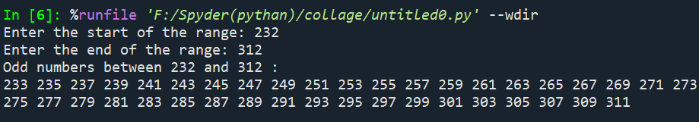

**Program 4:**

**Title of program:** Write a Python Program to Print Pascal Triangle.

**Objective:** This program helps us to print Pascal Triangle.

**Code:** def print_pascals_triangle(n):

triangle = []

for row in range(n):

new_row = [1] * (row + 1)

for col in range(1, row):

new_row[col] = triangle[row - 1][col - 1] + triangle[row - 1][col]

triangle.append(new_row)

width = n * 2

for row in triangle:

print(" " * (width - len(row)), end="")

print(" ".join(map(str, row)))

n = int(input("Enter number of rows: "))

print_pascals_triangle(n)

**Input:** number of row = 4

**Output:**

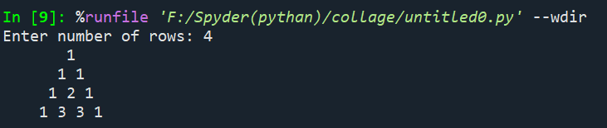

**Title of program:** WAP to draw the following Pattern for n number:

1 1 1 1 1

2 2 2 2

3 3 3

4 4

5

**Objective:** This program will draw the pattern above for n numbers.

**Code:** def draw_pattern(n):

for i in range(1, n + 1):

for j in range(n - i + 1):

print(i, end=' ')

print()

n = int(input("Enter the value of n: "))

draw_pattern(n)

**Input:** N = 5

**Output:**

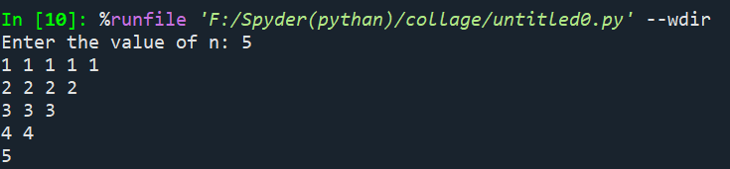

**Program 5:**

**Title of program:** Write a program with a function that accepts a string from keyboard and create a new string after converting character of each word capitalized.

**Objective:** This program will help us to capitalized all the words in a sentence.

**Code:** def capitalize_words(sentence):

capitalized_sentence = sentence.title()

return capitalized_sentence

sentence = input("Enter a sentence: ")

result = capitalize_words(sentence)

print("Capitalized sentence:", result)

**Input:** Sentence =stop and smell the roses

**Result:**

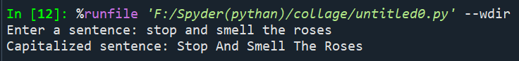

**Program 6:**

**Title of program:** Write a program that accepts a list from user. Your program should reverse the content of list and display it. Do not use reverse () method.

**Objective:** This program helps us to reverse the list.

**Code:** def reverse_list(lst):

reversed_lst = []

for i in range(len(lst) - 1, -1, -1):

reversed_lst.append(lst[i])

return reversed_lst

user_input = input("Enter a list of elements separated by space: ")

lst = user_input.split()

reversed_lst = reverse_list(lst)

print("Reversed list:", reversed_lst)

**Input:** list = 213,3123,123123,13123

**Result:**

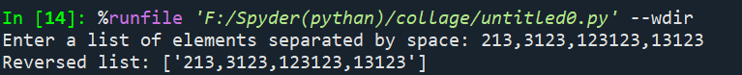

**Title of program:** Find and display the largest number of a list without using built-in function max (). Your program should ask the user to input values in list from keyboard.

**Objective:** This program will display largest number in the list.

**Code:** def find_largest_number(lst):

largest = lst[0]

for number in lst:

if number > largest:

largest = number

return largest

user_input = input("Enter a list of numbers separated by space: ")

lst = list(map(int, user_input.split()))

largest_number = find_largest_number(lst)

print("The largest number in the list is:", largest_number)

**Input:** List = 32131 3123 3123 12312

**Output:**

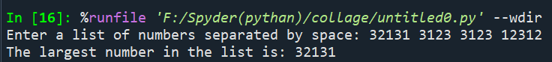

**Program 7:**

**Title of program:** Find the sum of each row of matrix of size m x n.

**Objective:** This program will find sum of each row in a matrix of size m x n.

**Code:** def sum_of_rows(matrix):

row_sums = []

for row in matrix:

row_sums.append(sum(row))

return row_sums

m = int(input("Enter the number of rows (m): "))

n = int(input("Enter the number of columns (n): "))

matrix = []

print("Enter the matrix elements row-wise:")

for i in range(m):

row = list(map(int, input().split()))

matrix.append(row)

row_sums = sum_of_rows(matrix)

for i in range(m):

print(f"Sum of row {i + 1} = {row_sums[i]}")

**Input:** Number of rows = 3

Number of columns = 4

Matrix = 2 11 7 12

5 2 9 15

8 3 10 42

**Result:**

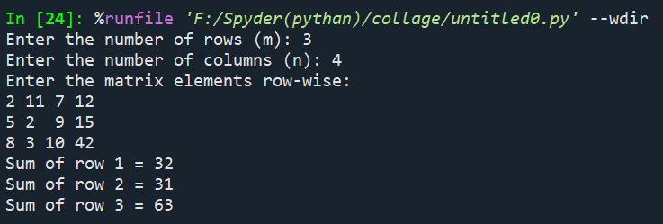

**Program 8:**

**Title of program:** Write a program that reads a string from keyboard and display:

* The number of uppercase letters in the string.

* The number of lowercase letters in the string.

* The number of digits in the string.

* The number of whitespace characters in the string.

**Objective:** This program will tell us letters are in uppercase or lowercase in string or there how many digits and backspace are there.

**Code:**  def count_characters(s):

uppercase_count = 0

lowercase_count = 0

digit_count = 0

whitespace_count = 0

for char in s:

if char.isupper():

uppercase_count += 1

elif char.islower():

lowercase_count += 1

elif char.isdigit():

digit_count += 1

elif char.isspace():

whitespace_count += 1

return uppercase_count, lowercase_count, digit_count, whitespace_count

input_string = input("Enter a string: ")

uppercase_count, lowercase_count, digit_count,

whitespace_count = count_characters(input_string)

print("The number of uppercase letters:",uppercase_count)

print(f"The number of lowercase letters:",lowercase_count)

print(f"The number of digits:",digit_count)

print(f"The number of whitespace characters:",whitespace_count)

**Input:** The line to be checked = Hi I am Coding in Python

**Result:**

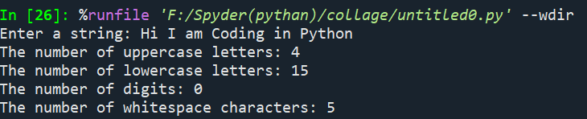

**Title of program:** [Python Program to Find Common Characters in Two Strings](https://www.sanfoundry.com/python-program-check-common-letters-string/).

**Objective:** This program will help to find common characters in two strings.

**Code:**  def find_common_characters(str1, str2):

set1 = set(str1)

set2 = set(str2)

common_chars = set1.intersection(set2)

return ''.join(sorted(common_chars))

string1 = input("Enter the first string: ")

string2 = input("Enter the second string: ")

common_characters = find_common_characters(string1, string2)

print("Common characters:",common_characters)

**Input:** First string = Aadit

Second string = Aadit Gupta

**Result:**

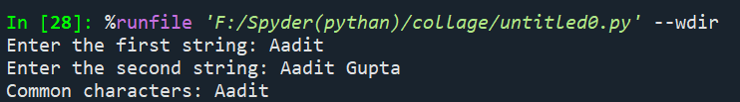

**Title of program:** [Python Program to Count the Number of Vowels in a String](https://www.sanfoundry.com/python-program-count-number-vowels-string/).

**Objective:** This program will count the number of vowels in a string.

**Code:** def count_vowels(s):

vowels = "aeiouAEIOU"

count = 0

for char in s:

if char in vowels:

count += 1

return count

input_string = input("Enter a string: ")

vowel_count = count_vowels(input_string)

print("The number of vowels in the string is:",vowel_count)

**Input:** string = Python

**Result:**

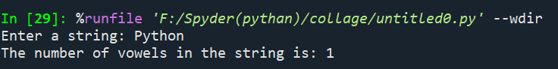

**Program 9:**

**Title of program:** Write a Python program to check if a specified element presents in a tuple of tuples. Original list:((‘Red’ ,’White’ , ‘Blue’),(‘Green’, ’Pink’ , ‘Purple’), (‘Orange’, ‘Yellow’, ‘Lime’)) Check if White present in said tuple of tuples! True

Check if Olive present in said tuple of tuples! False

**Objective:** This programwill check whether the mentioned elements are present in the tuple or not .

**Code:** def check_element_in_tuples(tuples, element):

for sub_tuple in tuples:

if element in sub_tuple:

return True

return False

tuples = (('Red', 'White', 'Blue'), ('Green', 'Pink', 'Purple'), ('Orange', 'Yellow', 'Lime'))

element1 = 'White'

element2 = 'Olive'

is_element1_present = check_element_in_tuples(tuples, element1)

is_element2_present = check_element_in_tuples(tuples, element2)

print("Check if",element1,"is present in the tuple of tuples:",is_element1_present)

print("Check if",element2,"is present in the tuple of tuples:",is_element2_present)

**Result:**

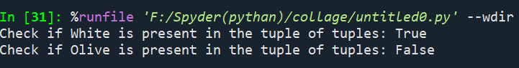

**Title of program:** Write a Python program to remove an empty tuple(s) from a list of tuples.

**Objective:** This program will remove the empty space in tuples.

**Code:** def remove_empty_tuples(lst):

return [t for t in lst if t]

sample_data = [(), (), ('',), ('a', 'b'), ('a', 'b', 'c'), ('d')]

result = remove_empty_tuples(sample_data)

print("After removing empty tuples:", result)

**Result:**



**Program 10:**

**Title of program:** Write a Program in Python to Find the Differences between Two Lists Using Sets.

**Objective:** This program will show the differences in two sets.

**Code:** def find_differences(list1, list2):

set1 = set(list1)

set2 = set(list2)

diff1 = set1 - set2

diff2 = set2 - set1

return list(diff1), list(diff2)

list1 = input("Enter the elements of the first list separated by space: ").split()

list2 = input("Enter the elements of the second list separated by space: ").split()

differences1, differences2 = find_differences(list1, list2)

print("Elements present in the first list but not in the second list:",differences1)

print(f"Elements present in the second list but not in the first list:",differences2)

**Input:** Elements of first list = 213 3221 321

Elements of second list = 123 3221 331

**Output:**

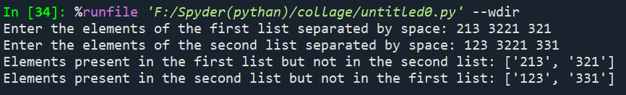

**Program 11:**

**Title of program:** Write a Python program Remove duplicate values across Dictionary Values.

**Objective:** This program will remove duplicate vales in dictionary.

**Code:** def remove_duplicates(test_dict):

seen_values = set()

for key in test_dict:

new_list = [val for val in test_dict[key] if val not in seen_values]

seen_values.update(test_dict[key])

test_dict[key] = new_list

return test_dict

test_dict1 = {'Manjeet': [1], 'Akash': [1, 8, 9]}

test_dict2 = {'Manjeet': [1, 1, 1], 'Akash': [1, 1, 1]}

result1 = remove_duplicates(test_dict1)

result2 = remove_duplicates(test_dict2)

print("Output for test_dict1:", result1)

print("Output for test_dict2:", result2)

**Output:**

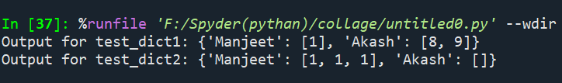

**Title of program:** Write a Python program to Count the frequencies in a list using dictionary in Python.

**Objective:** This program will count the frequencies in a list.

**Code:** def count_frequencies(lst):

frequency_dict = {}

for item in lst:

if item in frequency_dict:

frequency_dict[item] += 1

else:

frequency_dict[item] = 1

return frequency_dict

input_list = [1, 1, 1, 5, 5, 3, 1, 3, 3, 1, 4, 4, 4, 2, 2, 2, 2]

frequencies = count_frequencies(input_list)

for key, value in frequencies.items():

print(key,":",value)

**Input:** Input =[1, 1, 1, 5, 5, 3, 1, 3, 3, 1,4, 4, 4, 2, 2, 2, 2]

**Result:**

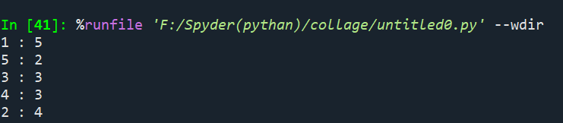

**Program 12:**

**Title of program:** Write a Python Program to Capitalize First Letter of Each Word in a File.

**Objective:** This program will Capitalize first letter of each word in a file.

**Code:** with open("TestCase.txt",'r') as f:

for line in f:

l=line.title()

print(l)

**Result:**

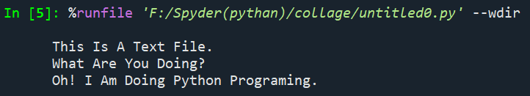

**Title of program:** Write a Python Program to Print the Contents of File in Reverse Order.

**Objective:** This program will print the contents of file in reverse Order.

**Solution:** filename = input("Enter the file name : ")

for line in reversed(list(open(filename))):

     print(line.rstrip())

**Input:** File name= Color.text

**Output:**

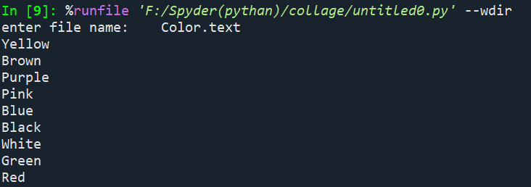

**Program 13:**

**Title of program:** WAP to catch an exception and handle it using try and except code blocks.

**Objective:** This code will give the dividend after dividing numerator and denominator.

**Code:** def divide_numbers(a, b):

try:

result = a / b

print(f"The result of {a} divided by {b} is {result}")

except ZeroDivisionError:

print("Error: Division by zero is not allowed.")

except TypeError:

print("Error: Both inputs must be numbers.")

except Exception as e:

print(f"An unexpected error occurred: {e}")

a = input("Enter the numerator: ")

b = input("Enter the denominator: ")

try:

a = int(a)

b = int(b)

except ValueError:

print("Error: Both inputs must be valid integers.")

else:

divide_numbers(a, b)

**Input:** Numerator : 242242

Denominator: 234242

**Result:**

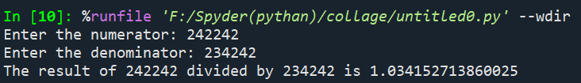

**Program 14:**

**Title of program:** Write a Python Program to Append, Delete and Display Elements of a List using Classes.

**Objective:** This program will help us to append, delete and display elements of a list.

**Code:** class check():

def __init__(self):

self.n=[]

def add(self,a):

return self.n.append(a)

def remove(self,b):

self.n.remove(b)

def dis(self):

return (self.n)

obj = check()

choice = 1

while choice != 0:

print("0.Exit")

print("1.Add")

print("2.Delete")

print("3.Display")

choice = int(input("ENTER CHOICE : "))

if choice == 1:

n = int(input("ENTER THE NUMBER TO APPEND : "))

obj.add(n)

print("List : ",obj.dis())

elif choice == 2:

n = int(input("ENTER THE NUMBER TO REMOVE : "))

obj.remove(n)

print("List : ",obj.dis())

elif choice == 3:

print("List : ",obj.dis())

elif choice == 0:

print("Exiting")

else:

print("Invalid Choice ! ")

print()

**Input:** Enter choice: 0

Enter the number to append: 2

Enter choice:3

Enter choice:0

**Result:**

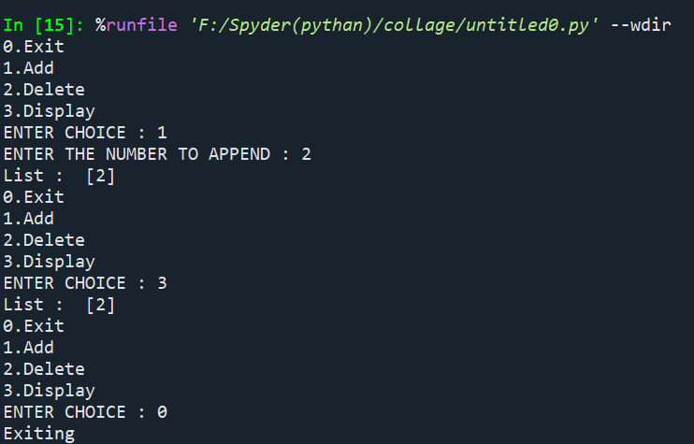

**Program 15:**

**Title of program:** Write a [Python Program to Find the Area and Perimeter of the Circle using Class](https://www.sanfoundry.com/python-program-class-compute-area-perimeter-circle/).

**Objective:** This program will give us the area and perimeter of circle when we will give the radius of circle.

**Code:** import math

class Circle:

def __init__(self, radius):

self.radius = radius

def area(self):

return math.pi * self.radius ** 2

def perimeter(self):

return 2 * math.pi * self.radius

radius = float(input("Enter the radius of the circle: "))

circle = Circle(radius)

circle_area = circle.area()

circle_perimeter = circle.perimeter()

print("Area of the circle:",circle_area)

print("Perimeter (circumference) of the circle:",circle_perimeter)

**Input:** Radius of Circle = 10

**Result:**

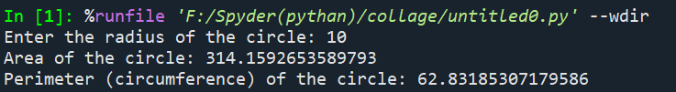

**Program 16:**

**Title of program:** Create an interactive application using Python's Tkinter library for graphics programming.

**Objective:** A working calculator.

**Code:** from tkinter import *

root = Tk()

root.title("Simple Calculator")

entry_field = Entry(root, width=35, borderwidth=5)

entry_field.grid(row=0, column=0, columnspan=4)

def button_click(number):

current_value = entry_field.get()

entry_field.delete(0, END)

entry_field.insert(0, str(current_value) + str(number))

def operator_click(operator):

current_value = entry_field.get()

entry_field.delete(0, END)

entry_field.insert(0, str(current_value) + str(operator))

def clear_button_click():

entry_field.delete(0, END)

def equals_button_click():

try:

result = eval(entry_field.get())

entry_field.delete(0, END)

entry_field.insert(0, str(result))

except Exception as e:

entry_field.delete(0, END)

entry_field.insert(0, "Error")

button_1 = Button(root, text="1", padx=40, pady=20, command=lambda: button_click(1))

button_2 = Button(root, text="2", padx=40, pady=20, command=lambda: button_click(2))

button_3 = Button(root, text="3", padx=40, pady=20, command=lambda: button_click(3))

button_4 = Button(root, text="4", padx=40, pady=20, command=lambda: button_click(4))

button_5 = Button(root, text="5", padx=40, pady=20, command=lambda: button_click(5))

button_6 = Button(root, text="6", padx=40, pady=20, command=lambda: button_click(6))

button_7 = Button(root, text="7", padx=40, pady=20, command=lambda: button_click(7))

button_8 = Button(root, text="8", padx=40, pady=20, command=lambda: button_click(8))

button_9 = Button(root, text="9", padx=40, pady=20, command=lambda: button_click(9))

button_0 = Button(root, text="0", padx=40, pady=20, command=lambda: button_click(0))

button_add = Button(root, text="+", padx=39, pady=20, command=lambda: operator_click("+"))

button_subtract = Button(root, text="-", padx=40, pady=20, command=lambda: operator_click("-"))

button_multiply = Button(root, text="*", padx=40, pady=20, command=lambda: operator_click("*"))

button_divide = Button(root, text="/", padx=40, pady=20, command=lambda: operator_click("/"))

button_equals = Button(root, text="=", padx=91, pady=20, command=equals_button_click)

button_clear = Button(root, text="Clear", padx=79, pady=20, command=clear_button_click)

button_1.grid(row=3, column=0)

button_2.grid(row=3, column=1)

button_3.grid(row=3, column=2)

button_4.grid(row=2, column=0)

button_5.grid(row=2, column=1)

button_6.grid(row=2, column=2)

button_7.grid(row=1, column=0)

button_8.grid(row=1, column=1)

button_9.grid(row=1, column=2)

button_0.grid(row=4, column=0)

button_add.grid(row=1, column=3)

button_subtract.grid(row=2, column=3)

button_multiply.grid(row=3, column=3)

button_divide.grid(row=4, column=3)

button_equals.grid(row=4, column=1, columnspan=2)

button_clear.grid(row=5, column=0, columnspan=4)

root.mainloop()

**Input:** calculation to be performed=100*21

**Result:**

